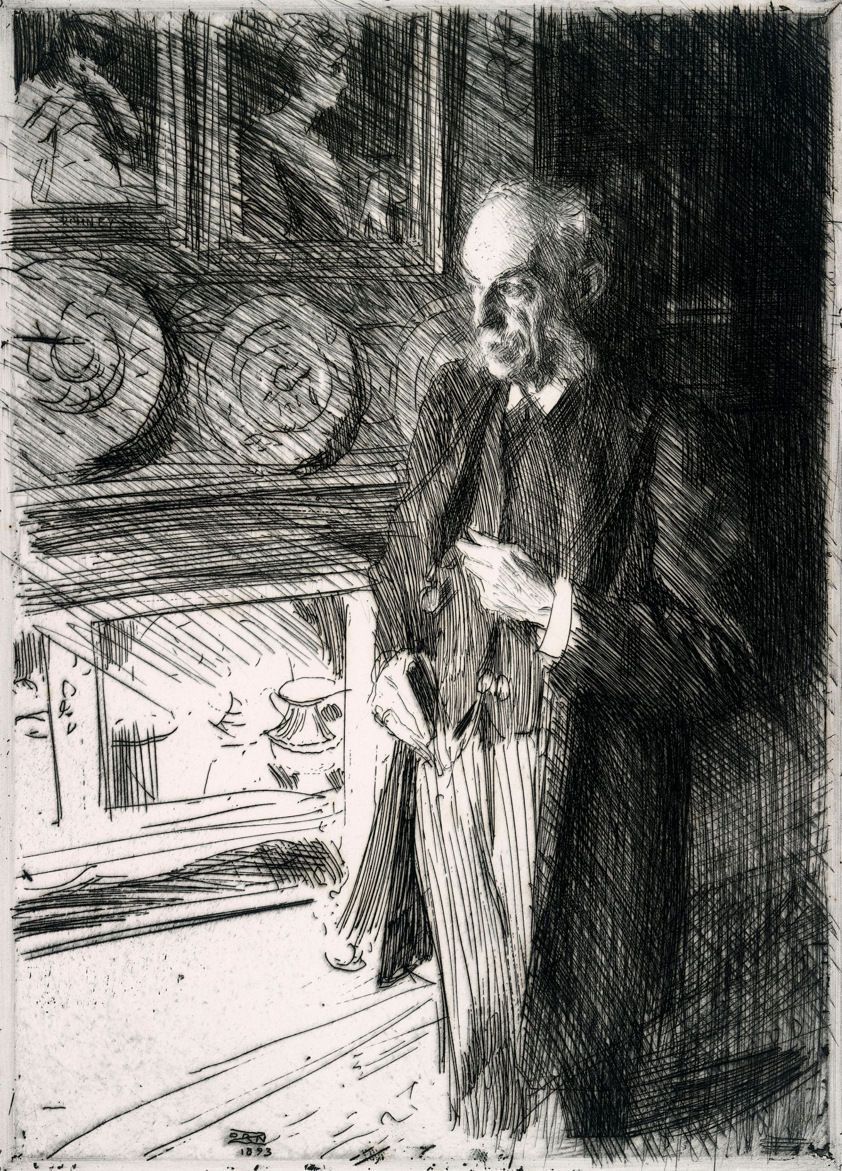

Photo © National Gallery of Ireland

**collectorscriticscurators2013@gmail.com**

**26 June 2013**

**Workshop**

**Treehouse, Humanities Research Centre, University of York**

**1.00pm**



**Synergies**

The Role of Collectors, Critics and Curators in Artistic Practice c. 1790-1914